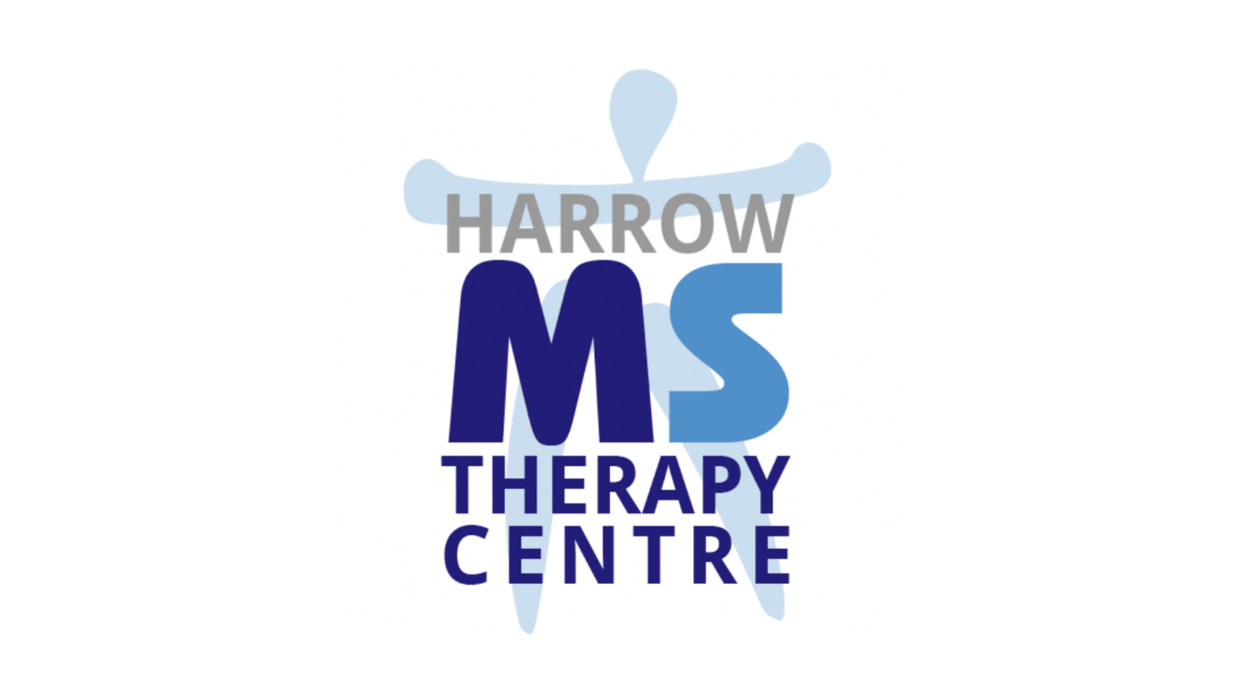

Welcome to the Harrow MS Therapy Centre

You, or perhaps someone you know, have been recently diagnosed, or maybe you have just heard about us. Either way, you have many questions, some of which we will deal with in this leaflet.

Since 1984 our Centre has enabled hundreds of people with Multiple Sclerosis to improve the quality of their life through offering a range of therapies, support, information and advice, all aimed at managing the disease and its symptoms.

The Centre offers a comfortable and relaxed environment for members, families and friends to relax and exchange ideas and solutions to any problems they may have. It helps to break down those feelings of isolation, helplessness and fear that come with the disease.

Therapies include:
- High Dose Oxygen Treatment
- Physiotherapy
- Yoga
- Chiropody
- Reflexology, Aromatherapy and Massage
- Information and Advice
- Companionship

What is Multiple Sclerosis?

MS is a disease of the central nervous system- the brain and spinal cord. For some unknown reason, Myelin (the protective coating surrounding all the nerve fibres in the central nervous system) is damaged. As a result messages travelling between the brain or spinal cord and a muscle or perhaps organ are not received properly, sometimes not at all. Depending where the damage has occurred symptoms could include weakness in the limbs. spasticity, fatigue, visual and sensory difficulties and bladder problems. There is nothing wrong with the actual muscles or sensory organs - it is simply that not all the messages are getting through.

The course of the disease is unpredictable. An attack can be followed by a period of remission, often lasting for years, or there may simply be a gradual deterioration.

Can MS be cured?

All those affected in the UK wish the answer was yes, but as yet no cure has been found.

Our emphasis is on treatment and management of the disease to provide the best possible quality of life.

High Dosage Oxygen Treatment

By breathing pure oxygen at more than atmospheric pressure a higher concentration can be absorbed into the blood and delivered to damaged tissue. This allows normal oxygen values to be established and thus promotes healing. The extra oxygen also greatly enhances the ability of white blood cells to kill bacteria and encourages new blood vessels to grow more rapidly into the affected areas.

HDOT takes places in a special chamber which is lightly pressurised with air at 1.5 to 2.5 times normal atmospheric pressure. The chamber can seat up to six people and pure oxygen is breathed through a face mask for an hour. During the initial daily sessions pressure may be varied to suit different needs and all responses are monitored and recorded by trained assessors.

Physiotherapy

Physiotherary plays a vital role in the management of MS. Our Centre has a team of physios experienced in neuro-disability: Members are assessed to identify any difficulties they are experiencing and a personal programme is then tailored to meet their needs. This will help to maximise movement and mobility thereby maintaining existing abilities for as long as possible. Physiotherapy helps to strengthen muscles, maintain control and co- ordination and reduce spasticity.

Other therapies
The other therapies listed are available at the Centre and play a major role in managing MS and achieving the best quality of life. We are very aware of all the stresses and strains of life without the added problem of MS
Where do I go from here?
This is a question everyone diagnosed with MS asks themselves. Sufferers, families and friends can quite simply feel lost. Help is only a phone call away. You will be given advice and information in a friendly and understanding way and you are welcome to come to the Centre and see what goes on.
How do we operate?
We are a registered Charity and a Company incorporated as the Harrow Multiple Sclerosis Therapy Centre Limited.
We operate on a self-help basis and the Centre is run by the members, for the members. We have a Centre Manager and Deputy Centre Mariager, a team of physiotherapists, qualified therapists offering other services and a wonderful group of volunteers.
We are a member of Multiple Sclerosis National Therapy Centres which maintains standards of operating practice

Who pays for the Centre?

The Charity's core therapies are free to all those affected by MS. The Centre is entirely self-funded and is totally dependent on regular voluntary donations.

Please call us:
Lynn Hurst
Miriam Franks

Harrow M.S. Therapy Centre
Harrow School Farm
Watford Road
Harrow HAT 3TS

Tel: 020 8423 6268

Email: enquiries@harrowmstherapy.co.uk
www.harrowmscentre.co.uk

