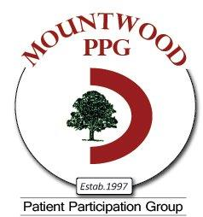

MOUNTWOOD PPG NEWS March 2018

This is shocking……..
DNAs (Did not attend)
In 2017 2032 patients did not
attend their appointment
339 hours wasted – which is an enormous drain
on the NHS and deprives other patients
in need of an appointment.
Don’t make an appointment for a future date in case you may need it.
If you find you don’t need your appointment
CANCEL IT

Did you know that Mountwood Surgery has a PPG (Patient Participation Group) and a Health Station?

The Mountwood PPG was established in 1997 and all Mountwood patients are entitled and welcome to become members. The PPG gives feedback on services Mountwood provides and helps tune the services to the needs of the patients. We also raise funds to buy equipment for the surgery that cannot be charged to the NHS and we organise surveys on a variety of topics.
At the moment the PPG meets at 2pm at Mountwood on the second Wednesday each month. These are informal friendly meetings. We would, in time, like to create a virtual (email) PPG membership with an occasional meeting (perhaps on a Saturday morning). This idea is for the future, but we will keep you informed of our progress. If you become a virtual member you would receive minutes of the PPG meetings, be able to make comments on the minutes and offer ideas.

MOUNTWOOD PPG NEWS continued……. March 2018

The Mountwood Health Station was established in 2007. Patients can ask for information, literature and also borrow CD’s on a variety of health issues. This can be very comforting to our patients and help them understand and learn how to cope with their problems and conditions. Advice can also be given about help available locally to the young, old and disabled.
In order for the PPG and Health Station to continue to run smoothly and to develop new ideas, we would like to invite more patients, just like you, to volunteer to help us, i.e. patients helping patients. We should stress, however, we do not get involved with individual health issues. We leave that to the professionals!
Whether you have lots of free time, or just a little, there is almost certainly something you can do to help.
If you are interested in becoming involved in either the PPG or the Health Station please contact: Mary Perkins at ppgmountwood@gmail.com or Ann Judge at mwhealthstation@gp-E86001.nhs.uk

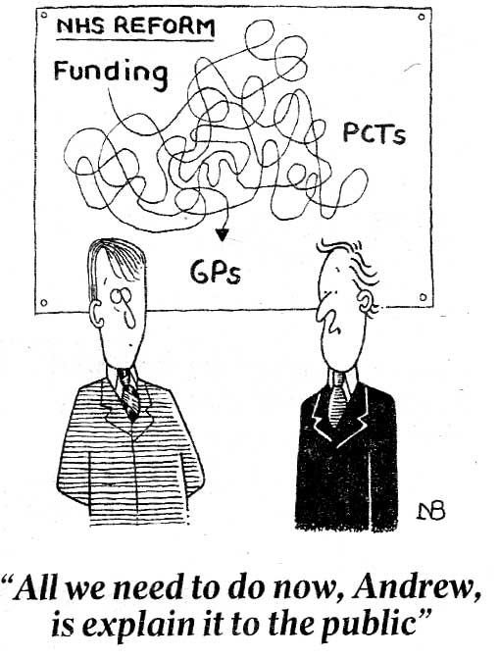
Other Matters…..
NHS England is trying very hard to reform the system.
It’s a vast organisation - let’s hope they succeed.
We will keep your informed of any changes to our
practice as and when they happen.

Did you know Mountwood Reception has a lost property box? Apparently lots of people leave their spectacles (and other things behind) when visiting a doctor or nurse. If you have mislaid any personal items please check with reception.

